

Submitted By:
Muhammad Ahmed Subhani
SU92 – BSSEM – S25 – 018
Section: 4-A

Submitted To:
Sir Rasikh Ali

Department of Software Engineering
Superior University, Lahore
Table of Contents
Using Minimax 3
1. Given data 3
2. Diagram 3
3. Calculation 4

LAB 5

Using Minimax

Given data
Value is given in the PDF:
scores = [3, 5, 2, 9, 0, 7]
We want a complete tree so we will add two 0 at the end:
[3, 5, 2, 9, 0, 7, 0, 0]
We do this to make the Level 3 more clear as stated in the diagram.
Minimax rule:
MAX picks out the biggest number.
MIN returns the smallest value.

Diagram
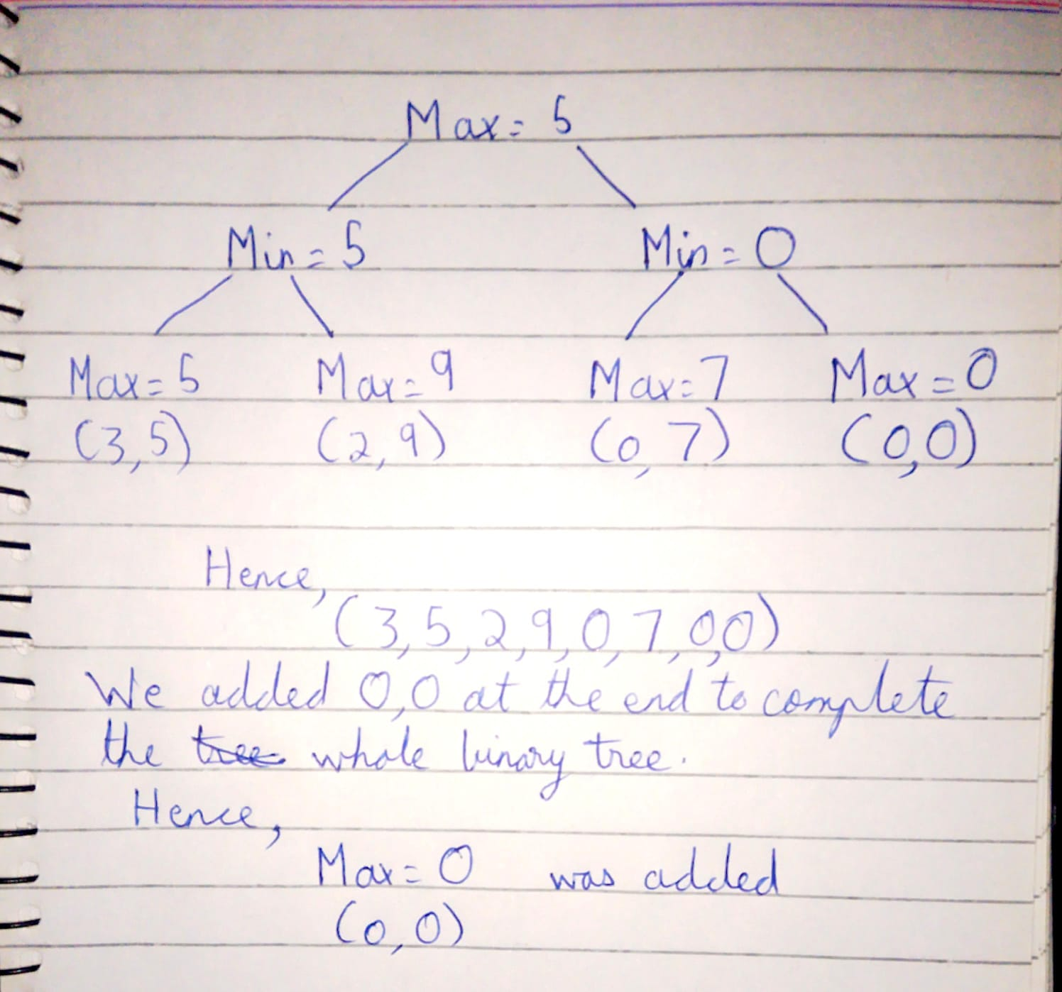

Calculation
Level 1
As stated in diagram Max chooses the largest value from each pair.
Hence;
max(3,5)=5
max(2,9)=9
max(0,7)=7
max(0,0)=0
Level 2
As stated in diagram Min chooses the largest value from each pair.
Hence;
min(5,9)=5
min(7,0)=0
Level 3
As stated in diagram the root Max chooses the largest value from each pair.
Hence;
max(5,0) = 5

